**Q5:** Discuss how your awareness of the omissions and/or marginalisations within a text shaped your response to its perspective(s).

The novel The End We Start From by Megan Hunter was published in 2017. It shows the absence of a father in a mother’s journey through a life of drastic change. Hunter influenced my response towards the experience of new mothers by causing me to feel inspired by the courage and determination to go through t

**Q5:** Compare how two texts of different genres respond to the concerns of the same time period.

Saving Ningaloo + Butterflies

The text “Saving Ningaloo Again” by Tim Winton was published on January 2019. It explores the effects of climate change on “Australia’s lesser-known coral treasure”, Ningaloo Reef. Winton responds to this issue by attempting to inspire the audience to restore the environment, and he does this through diction and repetition.

Quotes for B1:

* “…Ningaloo was safe”.
* “Ningaloo was safer”.
* “Saved, even”.
* “Gallop wasn’t punished for sparing the reef”.

Quotes for B2:

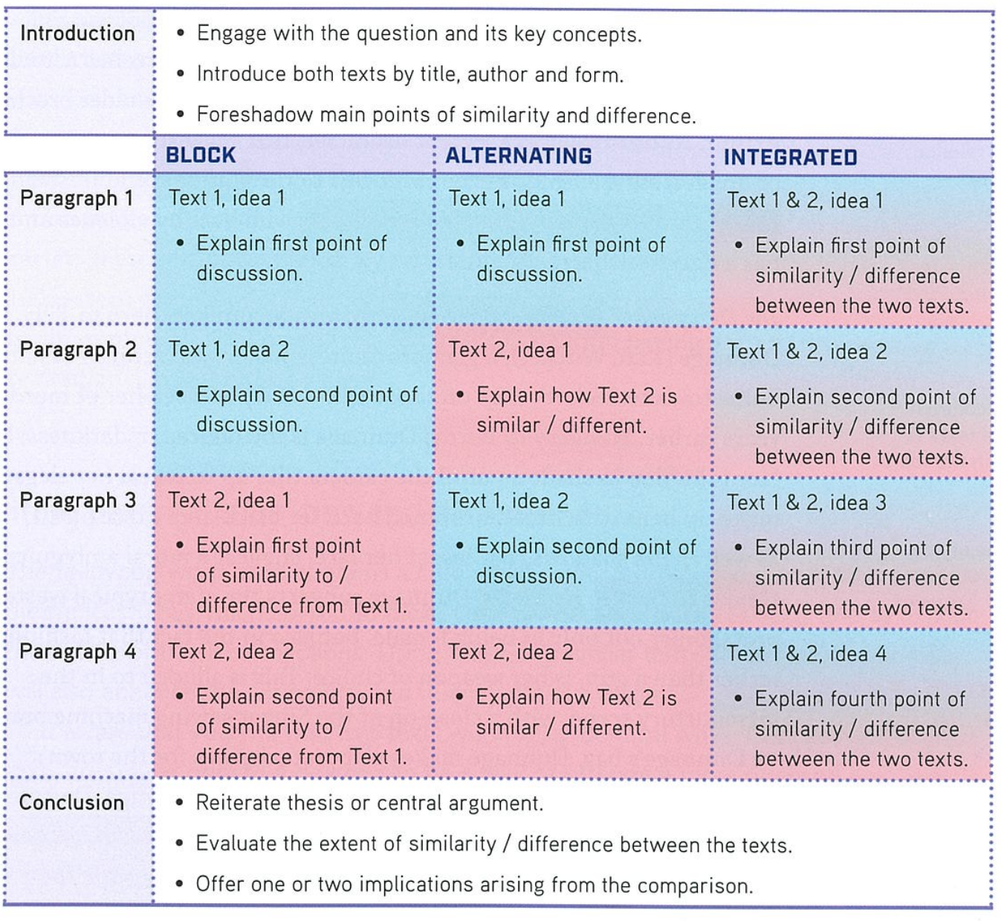

****Q5:** Compare how two texts of different genres respond to the concerns of the same time period.**

The text “Saving Ningaloo Again” by Tim Winton was published in 2019. Winton explores the effects of climate change on “Australia’s lesser-known coral treasure”, Ningaloo Reef. He responds to this issue by attempting to inspire the audience to restore the environment, and he does this through diction and repetition. The text “Butterflies” by Shaun Tan was published in 2018. Whilst Tan responds to a different issue within society, which is the inability of the urbanised mindset to be “in the moment” as society is constantly analysing and evaluating, he does this through diction and repetition as well.

Winton responds to the issue of human-induced climate change by attempting to inspire the audience to restore Ningaloo, creating a sense of hope and in doing so empowering the audience to save Ningaloo. He does this through a diction of protection. This can be seen throughout the text when Winton writes sentences such as “…Ningaloo was safe”, “Ningaloo was safer”, “Saved, even”, “But if you thought it was safe…” and “Ningaloo was safe”. This diction of protection emphasises the importance of the environment and how we are still able to save Ningaloo, inspiring the audience to do so.

Whilst Tan responds to a different issue, he uses the same devices to achieve the text’s purpose. Tan responds to how individuals living in urbanised areas are so focused on analysing information and evaluating patterns that we are unable to enjoy an experience whilst being fully ‘in the moment’. He does this through a scientific diction. When writing about how society will act once the butterflies leave, Tan writes that “Later we would study photo and video evidence with furrowed brows, listen to media analysis, consult scripture and meteorology, look at maps, graphs, stats and bell curves”. This use of scientific diction outlines the fact that society values scientific thinking where people analyse information and make conclusions. This in stark contrast to the excitement and joy when the butterflies came, as seen when people exclaimed “Hold still! Don’t move! ...”. This therefore shows that this scientific analytical thinking inhibits out ability to enjoy the present, outlining the issue of constant analysis and evaluation within our urbanised society.

Winton responds to the issue of destructive anthropogenic activity by conveying the message that Ningaloo Reef is much more damaged by the environment than most people think. He does this through repetition. Throughout the text, Winton has repeated use the word “isn’t”, as seen through quotes such as “Western Australia’s World Heritage site isn’t as protected as you’d expect”, “But because it’s so remote and in an arid zone where agricultural run-off isn’t an issue…”, “But here’s the thing: Ningaloo isn’t saved”, “It’s an uncomfortable reminder that LNG isn’t quite the clean energy alternative it’s marketed as”, along with others. This repetition of the word “isn’t” acts as a warning of the further damage that could be done to Ningaloo and has the effect of reminding the audience that their beliefs about Ningaloo’s state may not be necessarily correct. It portrays the message that we, as a society, have a responsibility to choose whether to “save Ningaloo” or not. This effectively responds to the issue of destructive anthropogenic activity by reminding the audience of the inadequate awareness of the consequences of human-induced climate change on Ningaloo.

Tan also uses repetition to respond to an issue but uses it to respond to the issue of the urbanised mindset being incapable of being “in the moment” due to constant analysis and evaluation. Tan uses repetition when he writes “What does it mean? What does it mean?”. This use of repetition portrays the idea that people value knowing what experiences mean, conveying the message that people are constantly analysing their environment and making evaluations and reasons for experiences. This portrays the desire of humans to understand the meaning of every phenomenon experienced, responding to the issue of the inability of the urbanised mindset to be “in the moment” due to constant analysis and examination by urbanised mindsets.

Saving Ningaloo Again:

Repetition of isn’t:

Winton

* Title: “Western Australia’s World Heritage site isn’t as protected as you’d expect”.
* “But because it’s so remote and in an arid zone where agricultural run-off isn’t an issue…”.
* “But here’s the thing: Ningaloo isn’t saved”.
* “It’s an uncomfortable reminder that LNG isn’t quite the clean energy alternative it’s marketed as”.
* Heron point: But this site isn’t just another scarred bit of Pilbara real estate; it’s deep inside Ningaloo’s refuge and nursery”.
* This repetition of “isn’t” acts as a warning to the audience about the further damage that could be done to Ningaloo, outlining the fact that we as a society have a responsibility to choose whether to “save Ningaloo” or not.
* This effectively responds to the issue of society being inadequately aware of the consequences of anthropogenic activity on Ningaloo.

Butterflies:

* “What did it mean? What did it mean?”
* As the narrator represents the internal thoughts of society as a collective whole, this repetition of “What did it mean?” emphasises the desire of society to understand the meaning of the natural phenomenon.
* This portrays the desire of humans to understand the meaning of every phenomenon experienced, responding to the issue of constant analysis and examination.

**Q8:** Compare how two texts of different modes use textual features to represent a similar idea or theme.

The End We Start From + Saving Ningaloo Again

**Q6:** Evaluate the way narrative point of view is used in two texts to convey specific values.

The End We Start From + Shrinking Sinking Land

**Q8:** Compare how two texts have been constructed for similar purposes, but through different genres.

The End We Start From + Andrew McConville

**Q: Explain how 2 texts of similar genres use specific language features to unsettle an audience.**

The text “Saving Ningaloo Again” by Tim Winton was published in 2019. Winton explores the effects of climate change on “Australia’s lesser-known coral treasure”, Ningaloo Reef. Winton attempts to unsettle his intended audience to further engage the audience, and he does this by using adjectives and verbs. The text “Natural gas has power to turbocharge economy” by Andrew McConville was published in 2021. McConville addresses the negativity surrounding the oil and gas industry regarding environmental destruction and proposes an alternate source of fuel in replacement to current main sources of fuel. McConville attempts to unsettle his intended audience to further engage the audience, and he does this by using repetition.

Winton explores the consequences of anthropogenic activity on Ningaloo and how we as a society are able to undo the damage if we are willing to. He engages his audience by attempting to unsettle them using adjectives. When writing about the northern reaches of Ningaloo Reef being “thoroughly encircled by oil-and-gas”, he writes that “at night the sinister flares on the horizon are hard to miss”. The use of the adjective “sinister” has negative connotations, implying that the flames are harmful and threatening. When Winton writes about Chevron’s new Wheatstone gas project, he describes the flames as “monstrous”. The use of the adjective “monstrous” also has negative connotations, implying ugliness and evil. When writing about the possibility of “a spill as catastrophic as the one at Montara” occurring at Ningaloo Reef, he writes that the locals of Ningaloo Reef “are certain something so dreadful could never happen”. The use of the adjectives “catastrophic” and “dreadful” unsettles the audience as it has negative connotations, implying that the issue being addressed is extremely serious and of great concern. This repeated use of adjectives with negative connotations has the effect of unsettling the audience as in the general population, the seriousness of the issue of climate change is not realised to a great extent and many individuals think that the mankind has enough time to just slowly progress towards lower levels of greenhouse gas emissions and destructive anthropogenic activity. This further engages the audience, causing them to be more engaged with the issue of human-induced climate change.

When writing about the building of a “500-hectare pipe-assembly and launch facility at Heron Point”, Winton writes that the project will involve a lot of “land-clearing, scouring, dredging and dragging”. These verbs are often connotated with removal, abrasion, destruction, change and force. The general population isn’t aware of the true extent of the amount of destruction to the environment caused by the oil and gas industry, so the use of these verbs outlines the effects of such projects by the oil and gas industry on the environment, unsettling the audience due to their lack of realisation and hence further engaging the audience.

McConville proposes an alternate source of fuel in replacement to traditional fuels which result in destruction to the environment. He engages his audience by attempting to unsettle them using repetition. In the first paragraph of the text, he writes “Imagine a world with no warmth for clean cooking and heating, no sustainable fuel… no glass, no clothing, no mobile phones, no steel, no concrete, no computers, no paints or plastics…”. This repetition of the word “no” emphasises the effects on society if the oil and gas industry were to vanish completely. This use of repetition unsettles the audience because the things that McConville listed are all things that we as a society are familiar with and deal with in our everyday lives, so this juxtaposition of reality to another reality with no oil and gas causes readers to question whether they want the oil and gas industry to vanish and whether it’s as destructive and evil to the environment as the media portrays it to be, hence unsettling the audience and further engaging them with his proposal of an alternate fuel source, which is natural gas.

****Q5:** Compare how two texts of different genres respond to the concerns of the same time period.**

The text “Saving Ningaloo Again” by Tim Winton was published in 2019. Winton explores the effects of climate change on “Australia’s lesser-known coral treasure”, Ningaloo Reef. He responds to this issue by attempting to inspire the audience to restore the environment, and he does this through diction and repetition. The text “Butterflies” by Shaun Tan was published in 2018. Whilst Tan responds to a different issue within society, which is the inability of the urbanised mindset to be “in the moment” as society is constantly analysing and evaluating, he does this through diction and repetition as well.

Winton responds to the issue of human-induced climate change by attempting to inspire the audience to restore Ningaloo, creating a sense of hope and in doing so empowering the audience to save Ningaloo. He does this through a diction of protection. This can be seen throughout the text when Winton writes sentences such as “…Ningaloo was safe”, “Ningaloo was safer”, “Saved, even”, “But if you thought it was safe…” and “Ningaloo was safe”. This diction of protection emphasises the importance of the environment and how we are still able to save Ningaloo, inspiring the audience to do so.

Whilst Tan responds to a different issue, he uses the same devices to achieve the text’s purpose. Tan responds to how individuals living in urbanised areas are so focused on analysing information and evaluating patterns that we are unable to enjoy an experience whilst being fully ‘in the moment’. He does this through a scientific diction. When writing about how society will act once the butterflies leave, Tan writes that “Later we would study photo and video evidence with furrowed brows, listen to media analysis, consult scripture and meteorology, look at maps, graphs, stats and bell curves”. This use of scientific diction outlines the fact that society values scientific thinking where people analyse information and make conclusions. This in stark contrast to the excitement and joy when the butterflies came, as seen when people exclaimed “Hold still! Don’t move! ...”. This therefore shows that this scientific analytical thinking inhibits out ability to enjoy the present, outlining the issue of constant analysis and evaluation within our urbanised society.

Winton responds to the issue of destructive anthropogenic activity by conveying the message that Ningaloo Reef is much more damaged by the environment than most people think. He does this through repetition. Throughout the text, Winton has repeated use the word “isn’t”, as seen through quotes such as “Western Australia’s World Heritage site isn’t as protected as you’d expect”, “But because it’s so remote and in an arid zone where agricultural run-off isn’t an issue…”, “But here’s the thing: Ningaloo isn’t saved”, “It’s an uncomfortable reminder that LNG isn’t quite the clean energy alternative it’s marketed as”, along with others. This repetition of the word “isn’t” acts as a warning of the further damage that could be done to Ningaloo and has the effect of reminding the audience that their beliefs about Ningaloo’s state may not be necessarily correct. It portrays the message that we, as a society, have a responsibility to choose whether to “save Ningaloo” or not. This effectively responds to the issue of destructive anthropogenic activity by reminding the audience of the inadequate awareness of the consequences of human-induced climate change on Ningaloo.

Tan also uses repetition to respond to an issue but uses it to respond to the issue of the urbanised mindset being incapable of being “in the moment” due to constant analysis and evaluation. Tan uses repetition when he writes “What does it mean? What does it mean?”. This use of repetition portrays the idea that people value knowing what experiences mean, conveying the message that people are constantly analysing their environment and making evaluations and reasons for experiences. This portrays the desire of humans to understand the meaning of every phenomenon experienced, responding to the issue of the inability of the urbanised mindset to be “in the moment” due to constant analysis and examination.

General Advice

Give context quotes:

* Who says it? What’s happening?
* Remember that the marker doesn’t know the text.

Introductions:

* Title, author, date of publication.
* Text summary.

Know more texts, know them in more detail and be flexible in answering the question.

POV:

* Don’t write about narrative POV.

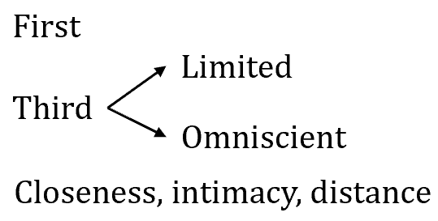

Identify the thing and then explain what it means?